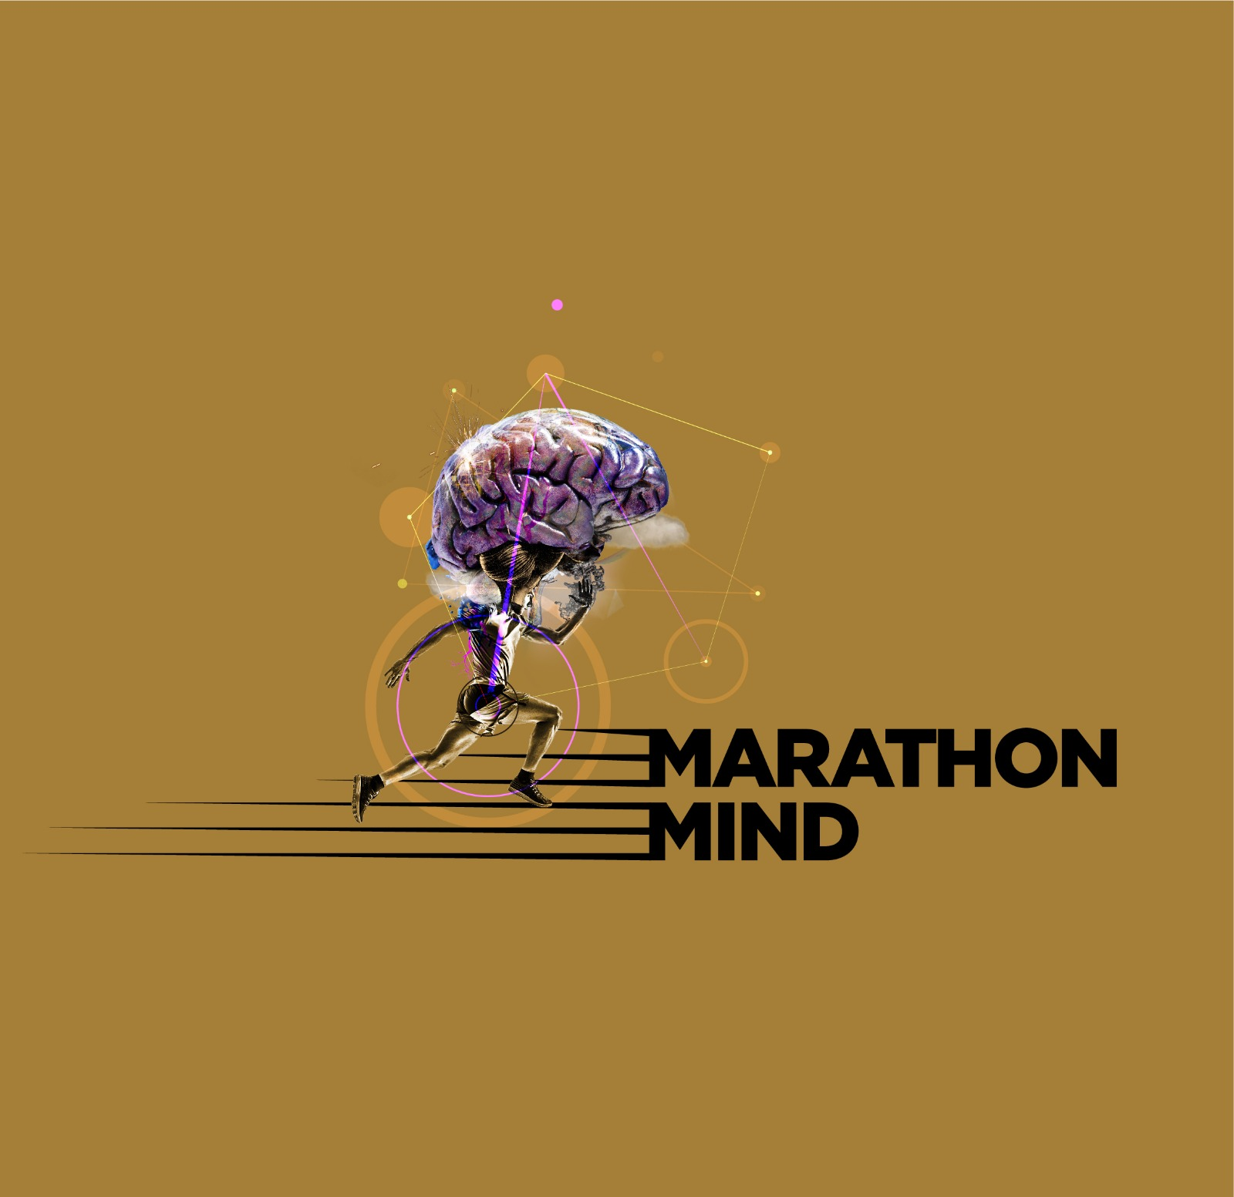
The Marathon Mind Psychologist

Louize Carroll

EPISODE SEVEN – PSYCHOLOGY SESSION PLAN

Dear Marathon Mind Listener,

Welcome back to the ‘Mind’ section of Marathon Mind!

THE HARE AND THE TORTOISE
We are all familiar with the old story of the Hare and the Tortoise and the lesson that teaches the benefits of being gradual and constant over the folly of speed and inconsistency.

This old story landed with me a different way today as I reflected on it.
The mind is like the hare. Speedy. Enthusiastic. Always running up ahead to see what’s there. Jumping into bushes if it gets spooked, into holes if it rains, running behind trees to hide from potential foxes, bounding through fields when it gets distracted from the path, looping backwards the odd occasion to see who is behind and to see what they may be doing. The hare is vigilant but sporadic. Hyper, and intense and because of this, on occasion, hares tend to burn themselves out. They go too hard too soon, and hit a proverbial wall.

The Tortoise on the other hand – the tortoise is our behaviour. The actions we take. The ‘one foot on front of the other’ despite what is going on in the environment, despite what is going on with the hare (read: the mind).
The tortoise takes action, it consistently moves. Even if it rains, it plods along. Even if there is a fox (or a calf injury!) – it stays on its path, and protects its extremities until the danger has passed. And when the coast is clear, on it plods.
The tortoise can see the hare bounding around in multiple different directions. It can see the hare’s capacity to clock danger faster than it can, but it also knows, that keeping a constant eye out for threat distracts from the action and from the goal. The only thing it can do regardless of what is up ahead, is to keep moving. One green little foot on front of the other. It knows that it’s got tools to deal with threat should danger emerge. Trusting how the process unfolds without having to control every detail.

The hare represents our mind’s capacity to generate all kinds of scenarios that distract us from action. And because our mind is our inner voice, our inner eye, and can create such a strong believable version of the future, it successfully hooks us time and time again and pulls us off course.
“Am I really able to do this?”, “Have I over-estimated my abilities?”, “I’m not as strong/fit/dedicated/good (insert own personal insecurity here) as everyone else”.

But the thing is, regardless of what the mind is chattering – we still have the capacity to CHOOSE to act. Despite feeling like sh*t, despite feeling like we may not get to the end, despite feeling doubt. The hare of our minds will always continue to bound around – it is a folly to wait for it to stop. It is a folly to wait for self-belief to return before you take further action. Our minds are wild hares for jayzus sake! You cannot tame a truly wild hare! And here’s where mindfulness is misinterpreted – it is not about taming the mind, it is about changing your relationship with your wild mind.
Separating your inner self into the part of you that does the thinking – and the part of you who watches yourself doing the thinking. Remember the two parts of you? You may have heard me speak about this before on the Marathon Mind Instagram and it bears repeating.

Mindfulness is about connecting with that part of you that has never been wounded. That central deep calm core of your soul. That tranquil ‘gut knowing’. I say ‘tranquil’ because if there is anxiety or intense emotion associated with what feels like a ‘gut knowing’ – then it is not a ‘gut knowing’, it is a trauma response. Therapy is brilliant for helping you get to know the difference between your own trauma responses and your own ‘gut knowing’ – but the calmness of the latter is your first clue.

But I digress - essentially what I’m saying is – getting hooked by the hare – stalls the tortoise.

But when you begin to see your ability to take action despite the wildness and convincing enthusiastic nature of the mind (hare), you have set yourself free from the confines of the mind and your emotions. And on you go.

To sum up:

THE HARE = THE MIND (can’t control it)

THE TORTOISE = STEADY PURPOSEFUL ACTION/BEHAVIOUR despite what the HARE is getting up to. (CAN control it)

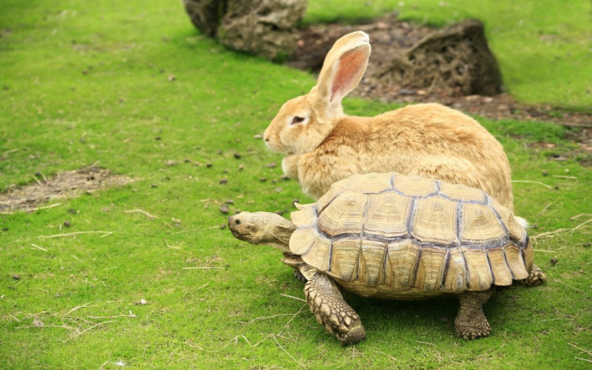

OUR NERVOUS SYSTEMS

Many of you by now are familiar with how I speak about the importance of the body. Researches and professionals have been speaking about this for years – e.g. The Body Keeps The Score by Bessel Van der Kolk and When The Body Says No by Gabor Mate.

Why do some people struggle to recover from trauma? Well, there may be multiple factors, but one is that they may never have addressed how trauma gets stored in our bodies. That is where it lives, if it does not get discharged appropriately at the time of the incident or chronic exposure to pain. Emotional or otherwise. Trauma doesn’t have to be a big trauma. Trauma can have a little ‘t’ as well. Consistent poor attunement from a parent or a partner. Poor self image because of poor mirroring and self concept development. There are lots of different kinds of trauma that each of us hold, to varying degrees. Our task is to try and identify how what we have experienced in our lives, contributes to the patterns of unhelpful thought patterns and then behaviours we find ourselves engaging in.

So even if we are doing things right, even if we are ticking boxes, eating right, sleeping well, getting the training miles in, if we have not learned how to regulate our nervous systems, such ‘activation’ (high heart rate, feelings of impending threat, shallow breathing) may continuously lead our minds into the interpretation that we are constantly under threat, leading us into a state of anxiety, with no obvious reason why (until we learn how to reflect on what’s happening).

But the good news is – you can learn to regulate your nervous system, which is turn sends a signal to your brain that you are SAFE.

Symptoms of a hyper-active dysregulated nervous system are:
- Over-reacting to real or imagined insignificant events
- Other people feel untrustworthy and/or look hostile most of the time
- Feelings of being out of control
- Feeling that you cannot cope a lot of the time
- Feeling resistant to the external world – it feels threatening

And an under-active dysregulated nervous system can also look like feeling very low and separate from the world:
- Feeling disconnected from other people most of the time
- Feeling like things are pointless
- Apathy
- Living in a fog
- Lacking energy and motivation

HOW TO REGULATE YOUR NERVOUS SYSTEM:

- Mindfulness Meditation
- CO-Regulation: With another person, friend, partner or sibling, sit opposite one another on the floor. Put a hand on their heart, and have them put a hand on your heart. And breathe – mindfulness breathing in synchrony with each other, with your eyes closed. Do it for 2 minutes, and notice how you feel. Remind each other you are safe.
- Implement better boundaries to protect your energy in all areas of life.
- Dance – wildly and unselfconsciously (you may scoff at this, but it’s powerful!!)
- Have a cold shower or jump in the sea (provided you can swim, I’m not sure I have to say that, but, you know, just in case).

GOOD LUCK, UNTIL NEXT TIME.

Louize

