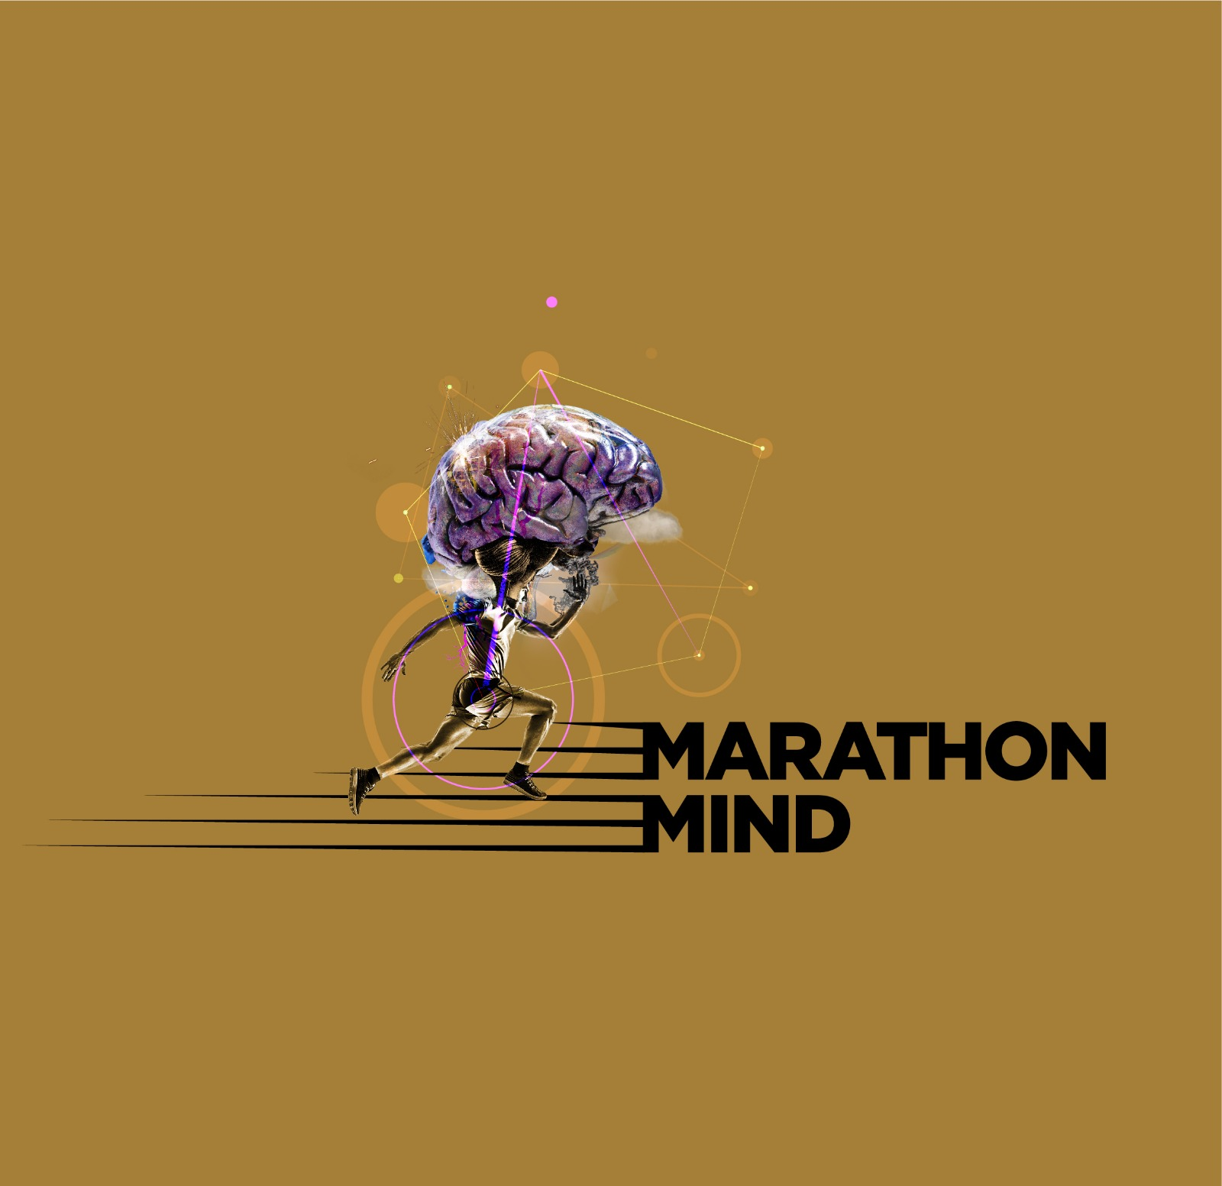
The Marathon Mind Psychologist

Louize Carroll

EPISODE EIGHT – PSYCHOLOGY SESSION PLAN

Dear Marathon Mind Listener,

Welcome back to the ‘Mind’ section of Marathon Mind!

BEAUTY – LEARN TO SEE IT IN ‘THE SPACES BETWEEN’.

“What we are afraid of is not our limitations, but the infinite within us.”
Mandela

John O’Donohue said that beauty is not a luxury, but that it enobles the heart and reminds us of the infinity that is within us.
What he meant by beauty, is anything which brings us joy, peace and makes us feel a deep knowing and love within. This is our power, our capacity and our feeling of infinity. It is embodied by that which brings us back into rhythm with nature. That which makes us feel fully alive. The scent of the forest. The breath of the sea air. The infinite view of the mountains. The way the light falls on the landscape and causes you to catch your breath. The laugh of a friend and the smile from a stranger. The electricity you feel when you hear someone articulate something that you feel yourself. The buzz you might get from achieving something you never thought you could do or perhaps something that you wanted, but feared at the same time.

A significant portion of you may fall into these last two categories. And. Look. At. You. Now. Some of you may still be hovering around the 10km mark, that’s ok. Keep moving. If that feels right for you. And some of you, including our marathon mind rockstars, have moved towards and into the 30km mark.

- Feel all of this.
- Take stock of the effort you have put in.
- Recall the sacrifices you have made and continue to make in pursuit of a goal in your own wonderful honour.
- Really feel it in your body. Where do you feel it?
- Notice the sensations.
- Acknowledge yourself and how far you have come, physically and emotionally.
- Celebrate it.
- And as a favourite yoga teacher Jenny Keane says – “lift the corners of your lips…………..UP”.

That is as much a part of your journey on this programme as is the miles in your legs.

MORE ABOUT BEAUTY…

Why? What’s it got to do with the mind or the marathon?
Because when we begin to notice beauty, we start to enliven ourselves. We enhance our capacity for gratitude, and gratitude boosts our mood and lowers feelings of dissatisfaction. We plug in to the electricity of life, and we become motivated by this power.

Motivated to hold things lightly so we can still move freely, in the pursuit of our goals.

The beauty in your life and in your journey that I want you to connect with is not necessarily about aesthetic and it’s not at all about superficiality. It’s about possibility, imagination, courage and creativity. It could be nature, music, friends, philsophers’ words or the limitless imagination we have the capacity to embrace. The deep inhale you take when you hear something that resonates with you. The sights you see out on your long runs. The amusing thoughts or creative ideas that occur to you along the way. It’s about connecting bravely to that which moves us into alignment with ourselves.
Because, perhaps most critically of all, the greater the distance and dissonance between our inner world (in how we think, feel and what we want), and in how we actually choose live our lives on the outside, - i.e. the company we keep, the relationships we foster, the career we persist in - the greater the propensity for dissatisfaction, and in fact the larger the susceptibility for persistent feelings of anxiety and low mood.

KNOW THY SELF

Some of you have gotten in touch over the course of the last eight months and have been so generous in letting me know how your lives are going. Some of you are thriving, and some of you hit the largest of difficulties, but have found strength within you that you never knew you had. I love these messages and I am so honoured and moved by those of you who have shared your stories with me.

Some of the truths you’ve shared with me have been about how lost you have felt behind what you believed was expected of you in your lives, versus what or who you really were or wanted deep down.

In the digital world, it is easier and more tempting than ever to lose or conceal ourselves behind a carefully curated projection of who we think is more acceptable/desirable/’insert chosen characteristic here’. The closer we align with superficiality, with appearance, with the outward projection of a desired image, the more we move away from knowing ourselves. The more we blunt our individuality and our uniqueness, and the more we stunt the expression of our full and authentic selves.

In real life, the more we pretend and say we are ‘fine’ when we are not, the more we deny ourselves the opportunity to create a better more fulfilling life for ourselves. It comes back to realising again, (and yes I will continue to bang on about this) that at every, and any, stage:

YOU
HAVE
A
CHOICE

And bear in mind that every choice you make, every decision you take, will involve saying NO to something or someone.

But that is necessary in order to stop saying NO to yourself.

Other truths that have been shared with me have been serious loss or devastating life changes.
Sometimes it is grief, or a very tangible threat to the way we currently live, that is the thing that takes us closer to our core. With this, we have no choice, we are roughly forced to face reality. This might be the loss of a loved one. It might be the destruction of a once important and central relationship. It might be the loss of your identity or what you once believed to be true. It might be all of these things together, and my god it can hurt. Your whole life could be turned upside down and you’re left staring at an external and perhaps even an internal empty space. It can be terrifying. But it is raw. It is true. And there is beauty in both rawness and truth.

You won’t catch a person who’s come up close and personal to the searing edge of existential crisis to sugar coat theirs or any other reality. Suddenly the most important aspects of living move into the sharpest focus, and any nonsense and fluff circulating around honesty and trust is abolished. It takes us right into the hot, molton core of our being, and makes us aware of the blood coursing through our veins, our beating heart, and all that we value and all that we do not value in this life.

It is painful but we are moving into alignment.

Don’t wait.

REFLECT AND RESPECT

This month, your mission is to review your work in the past 8 months.

- Have your initial intentions and reasons behind running the marathon stayed the same, or have they changed?

- How has your relationship with your emotions changed?

- How has your relationship with your thoughts changed?

- How has your relationships with your body changed?

- And with food?

- And how has your relationships with others changed?

- Have your feelings and attitudes towards yourself changed in any way?

- Maybe not too much as changed at all, and that’s ok. But if it has, notice it.

- What have you learned? What is different in you compared to when you started out on this journey nearly eight months ago?

- On a scale of 1-10, where do you rate yourself on self-worth, on self-confidence, on self-compassion? Do you think this differs to how you might have rated yourself back in March?

- And finally, I want you to give yourself and giant helping of absolute respect for what you have achieved so far. No matter how far. Life is a jumble of a variety of options. We can opt out or we can opt in. You opted in. RESPECT.

Talk to you all for our final plan next month.
Until then…

Louize

